QUESTION ONE
a)Purpose of Access Modifiers in OOP.
Access modifiers in OOP control the visibility and accessibility of classes, methods, and variables. They enforce encapsulation by restricting direct access to an object's internal data, preventing unauthorized modification and maintaining data integrity. The four access levels in Java help implement the principle of information hiding, where implementation details are concealed while exposing only necessary interfaces.

b) Access Modifiers Table Completion
Access Modifiers | public | protected | default | private
Defining class | ✓ | ✓ | ✓ | ✓
Class in same package | ✓ | ✓ | ✓ | ✗
Subclass in different package | ✓ | ✓ | ✗ | ✗
Non-subclass in different package | ✓ | ✗ | ✗ | ✗

C) Java Application for Accommodation Areas.
Code:
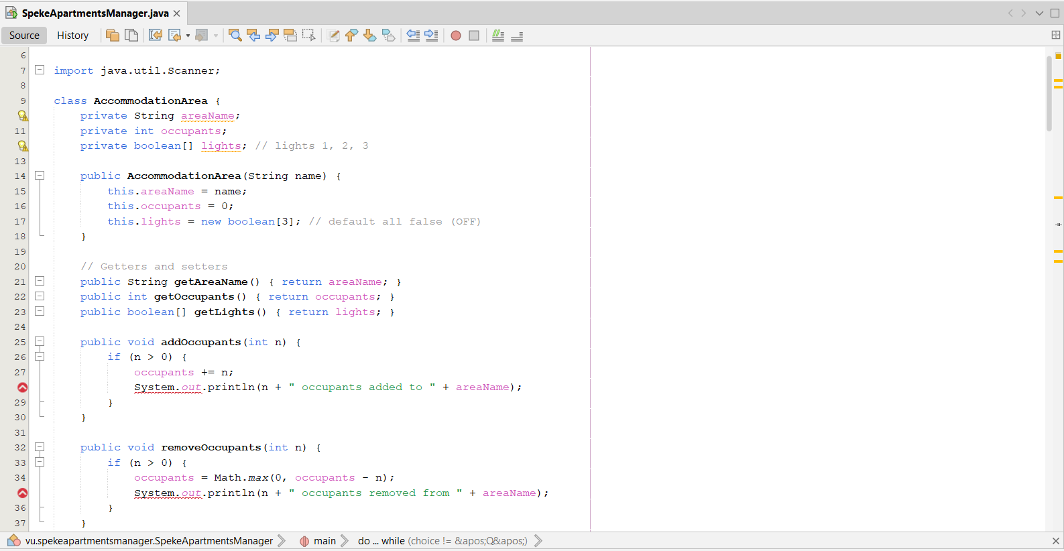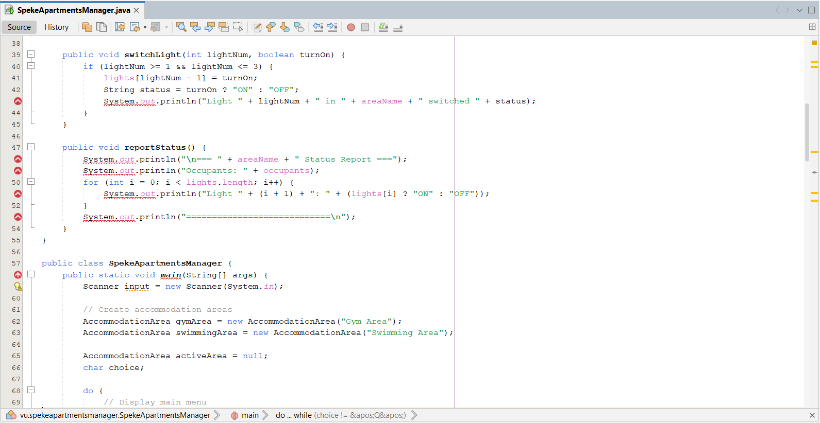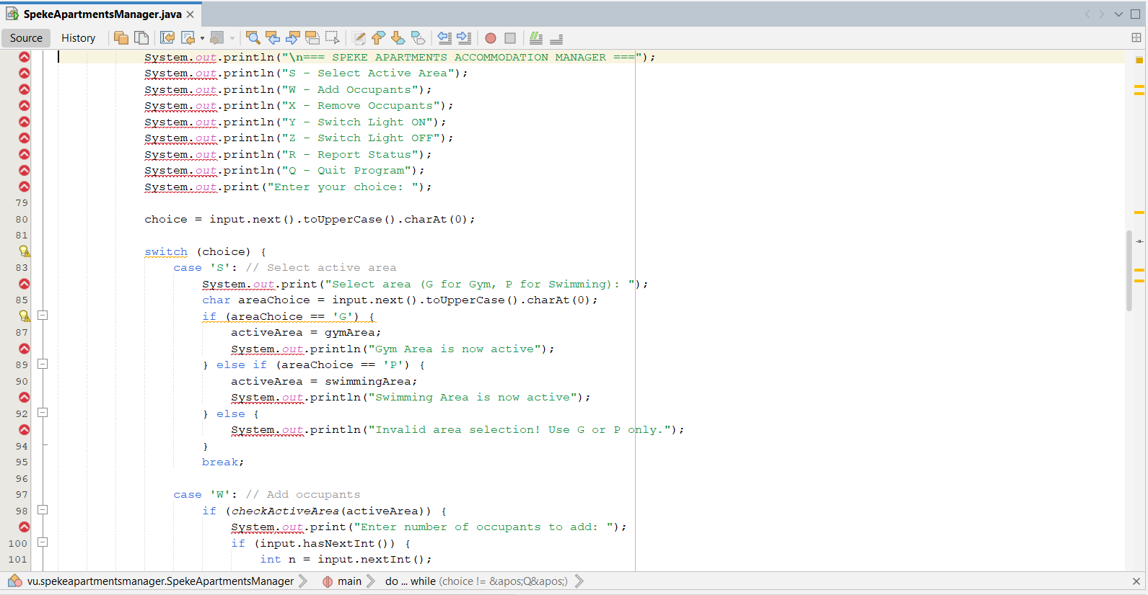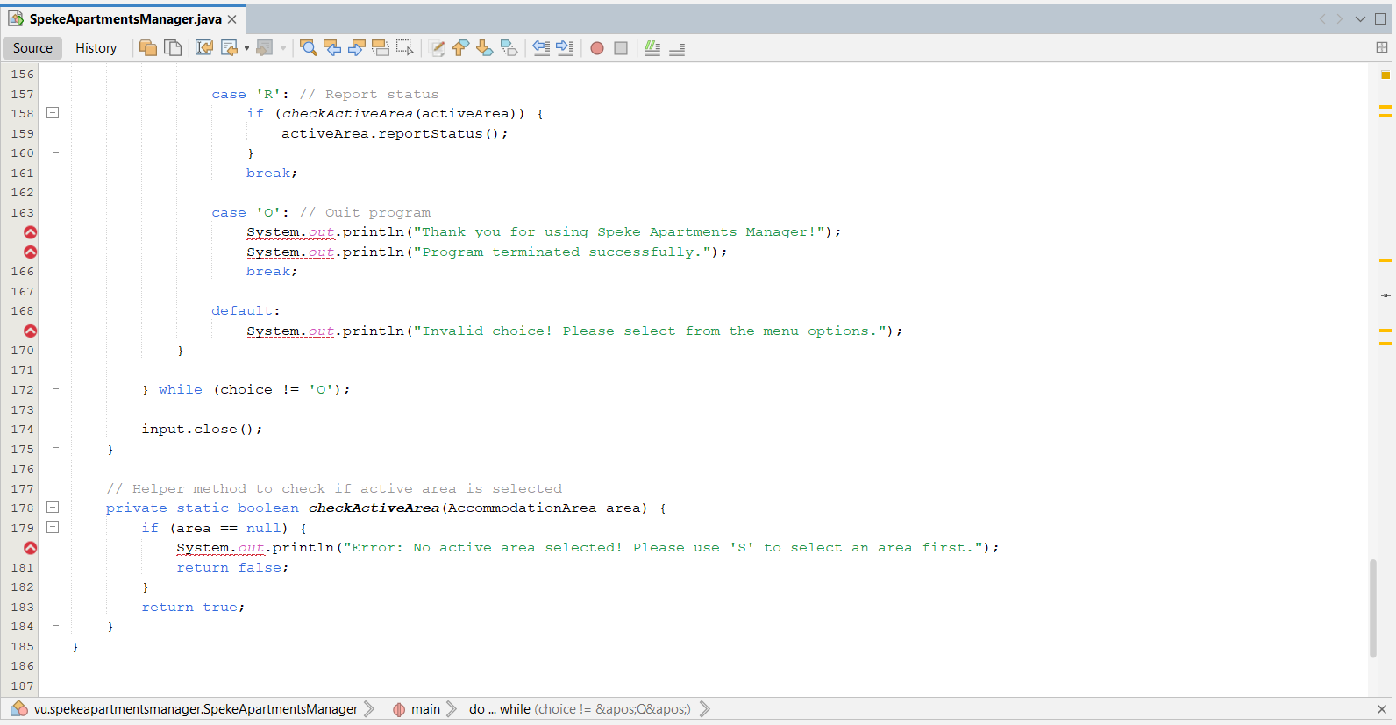

OUTPUT:
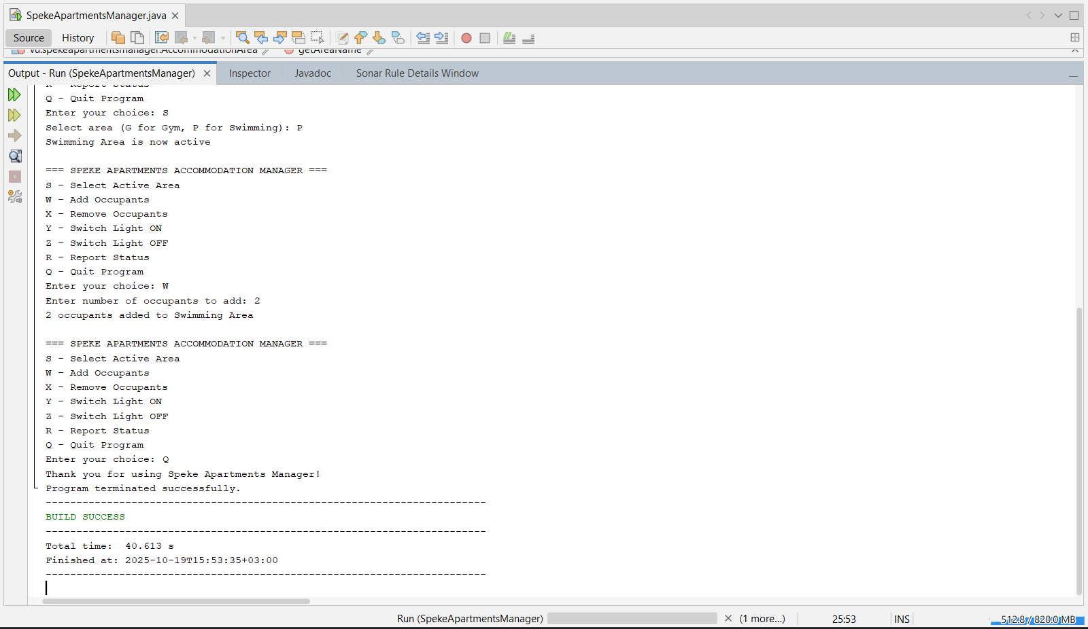

GitHub Link:
https://github.com/joepro29/Question1-Accommodation-Area.git

QUESTION TWO
- Elite SACCO Investment Calculation

Code:
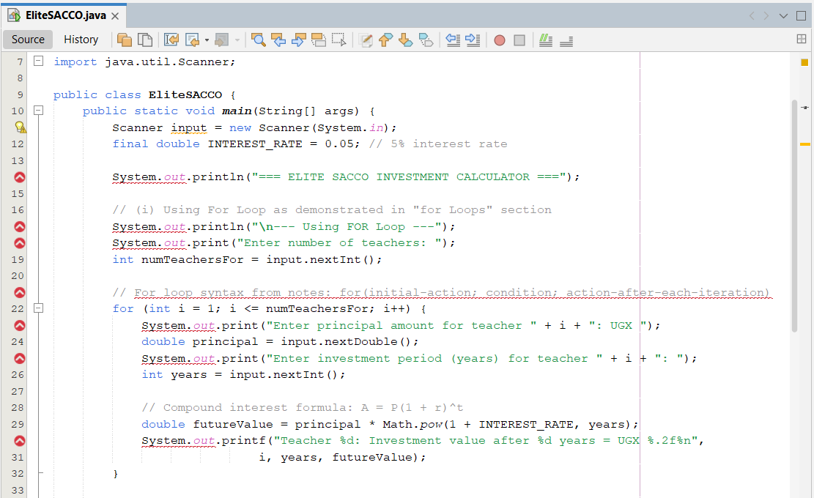
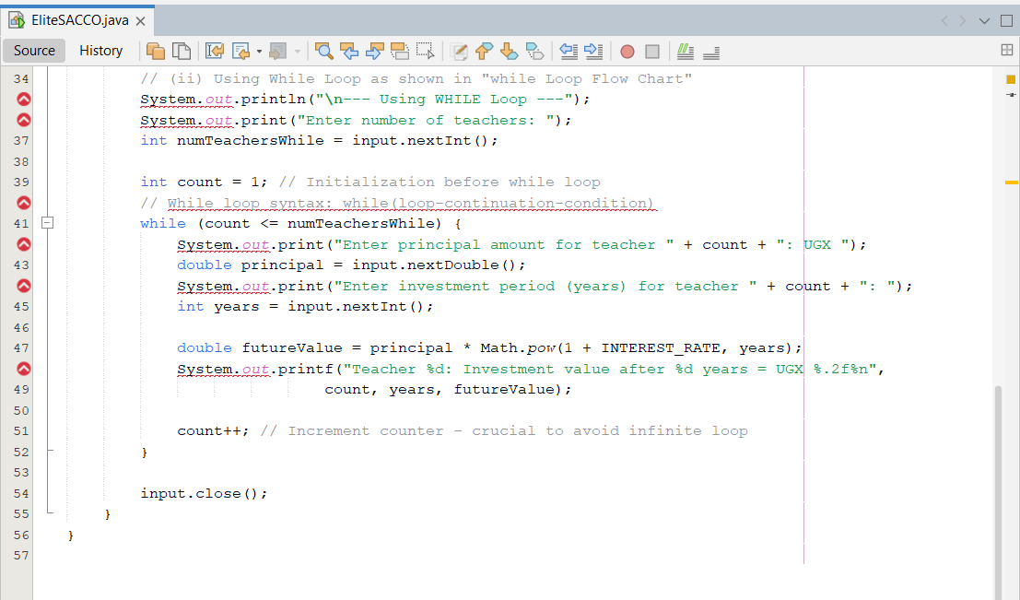

OutPut:
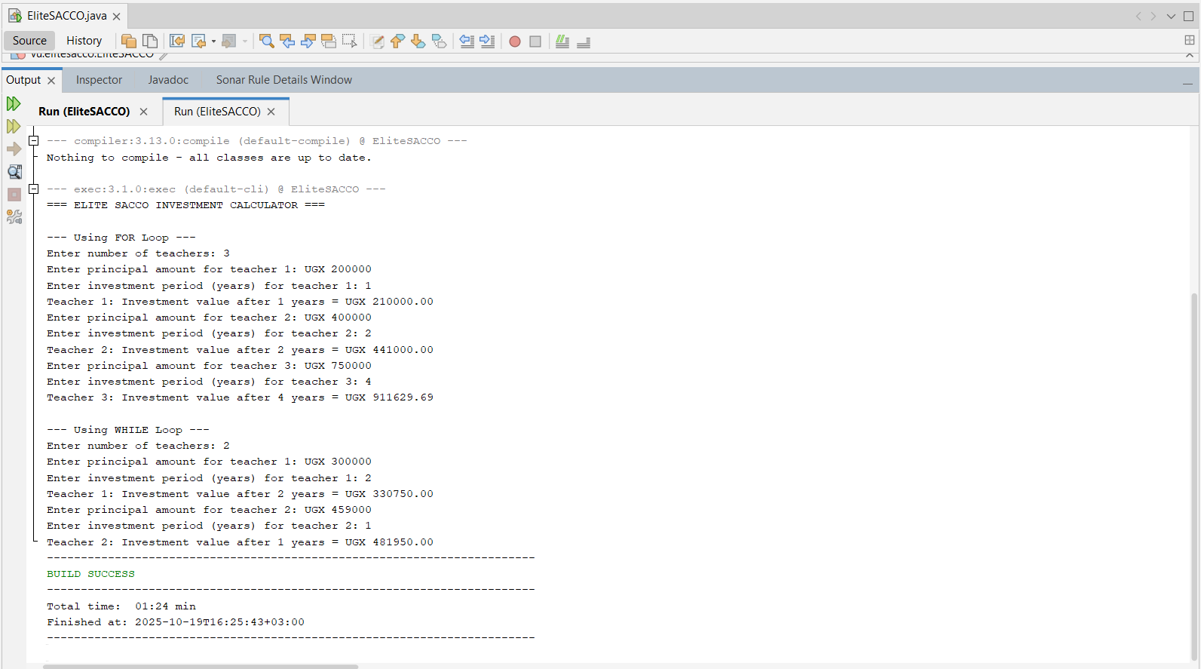
GitHub Link
https://github.com/joepro29/Elitesacco.git

(b) Concave Mirror Focal Length Verification

Code:
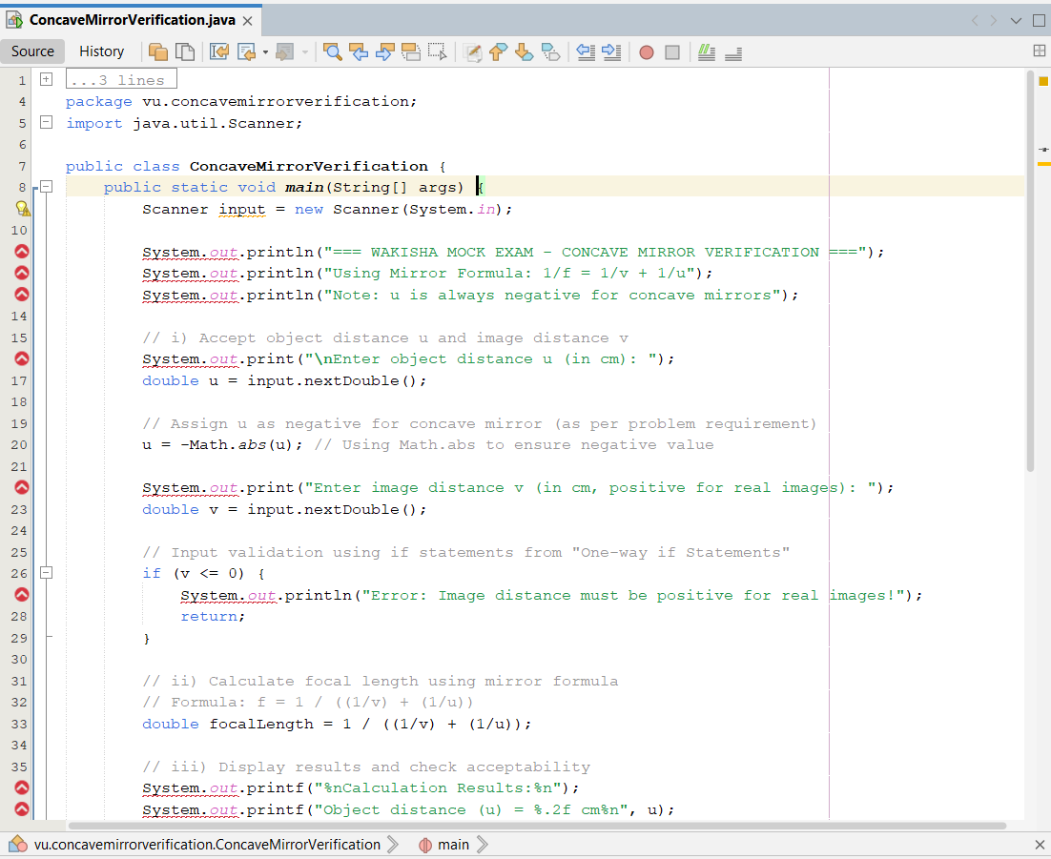
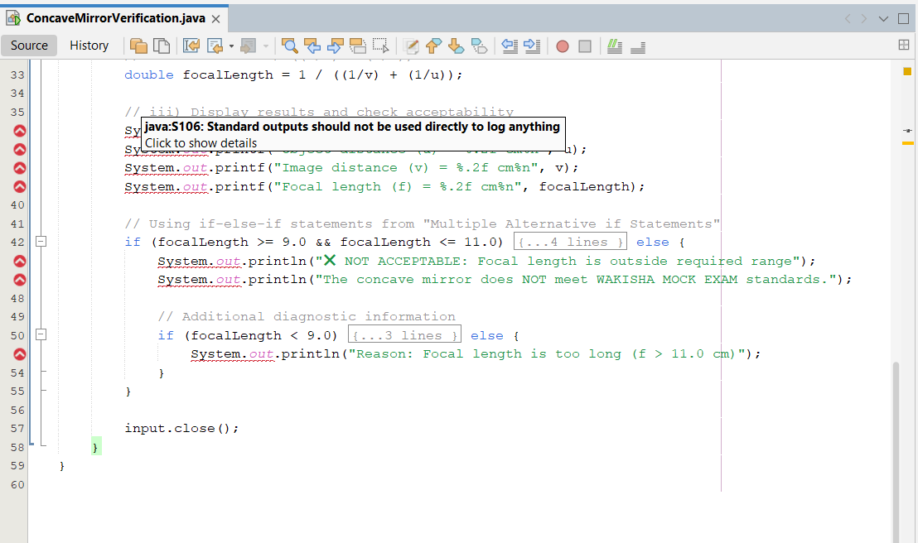

OutPut:
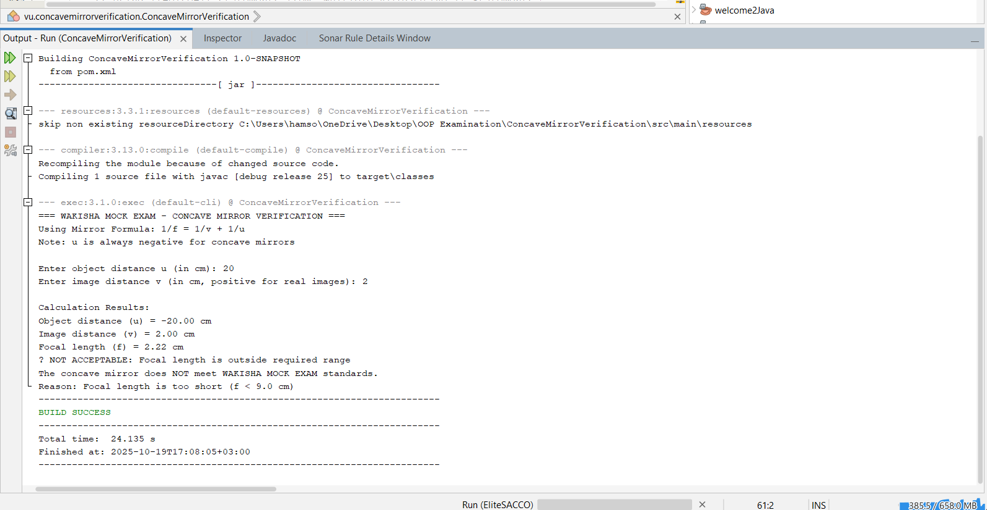

GitHub Link:
https://github.com/joepro29/ConcaveMirrorVerification.git

C)Code Analysis and Output.
Code:
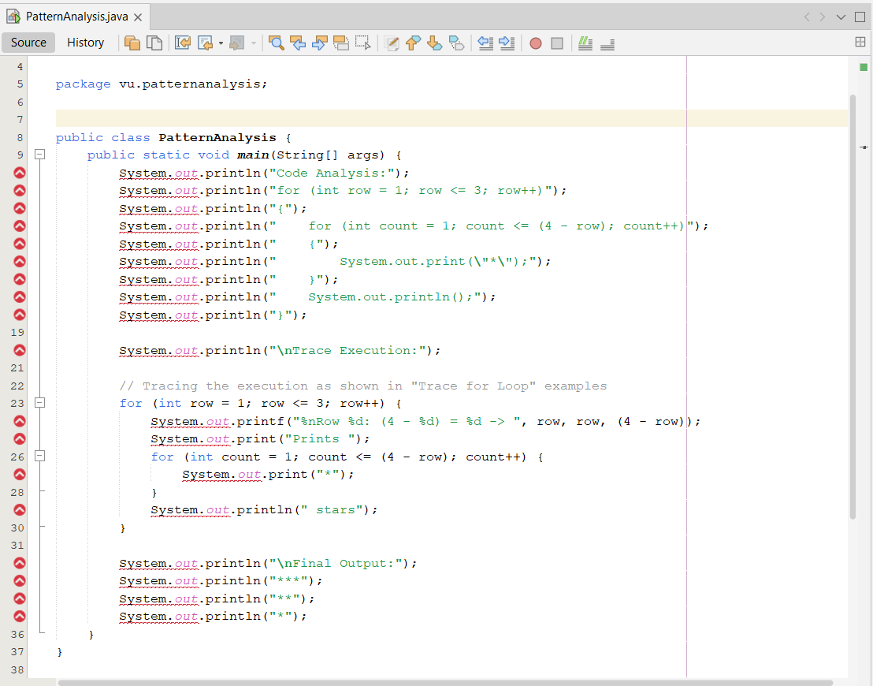
OutPut:
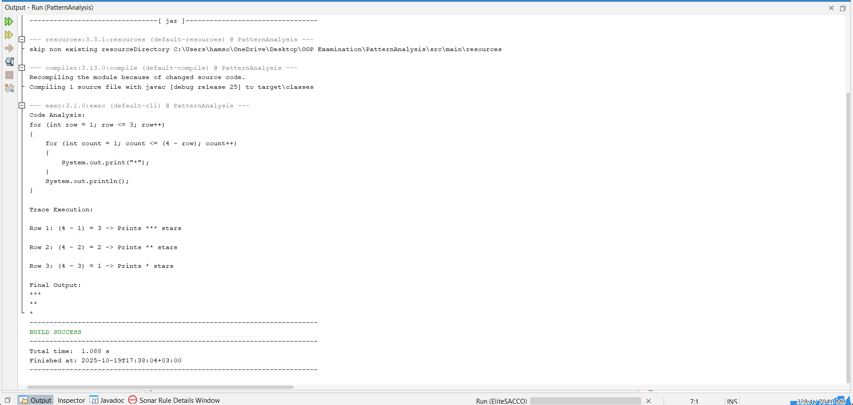
GitHub Link:
https://github.com/joepro29/patternanalysis.git

QUESTION FOUR
(a) Deployment of Arrays in Programs
- Single-Dimensional Arrays: Array is a data structure that represents a collection of the same types of data.
Example:
Int[] scores = {90, 80, 70, 60};
System.out.println(scores[0]); //output: 90

- Multidimensional Arrays : To give examples of representing data using two-dimensional arrays.
Example:
//2D array (3x3)
Int[][]matrix = {
{1, 2, 3},
{4, 5, 6},
{7, 8, 9}
};
System.out.println(matrix[0][1]); // Output: 2

- Baby's Meal Scheduling Program.

Code:
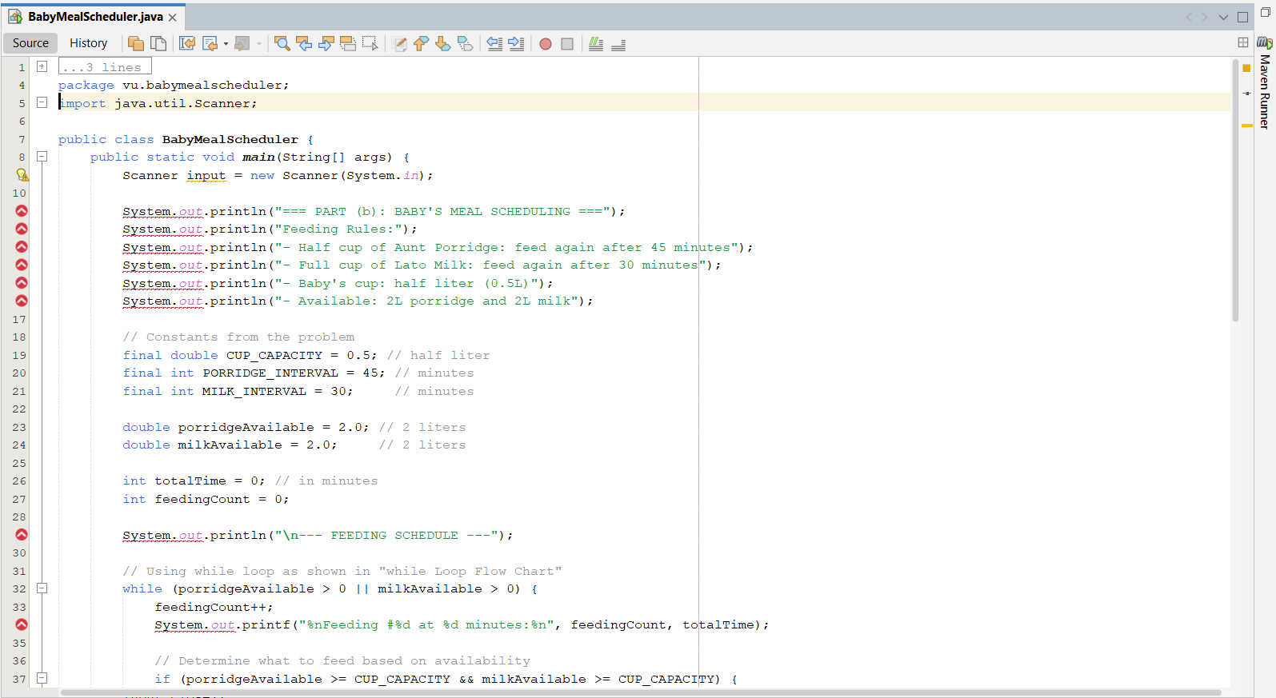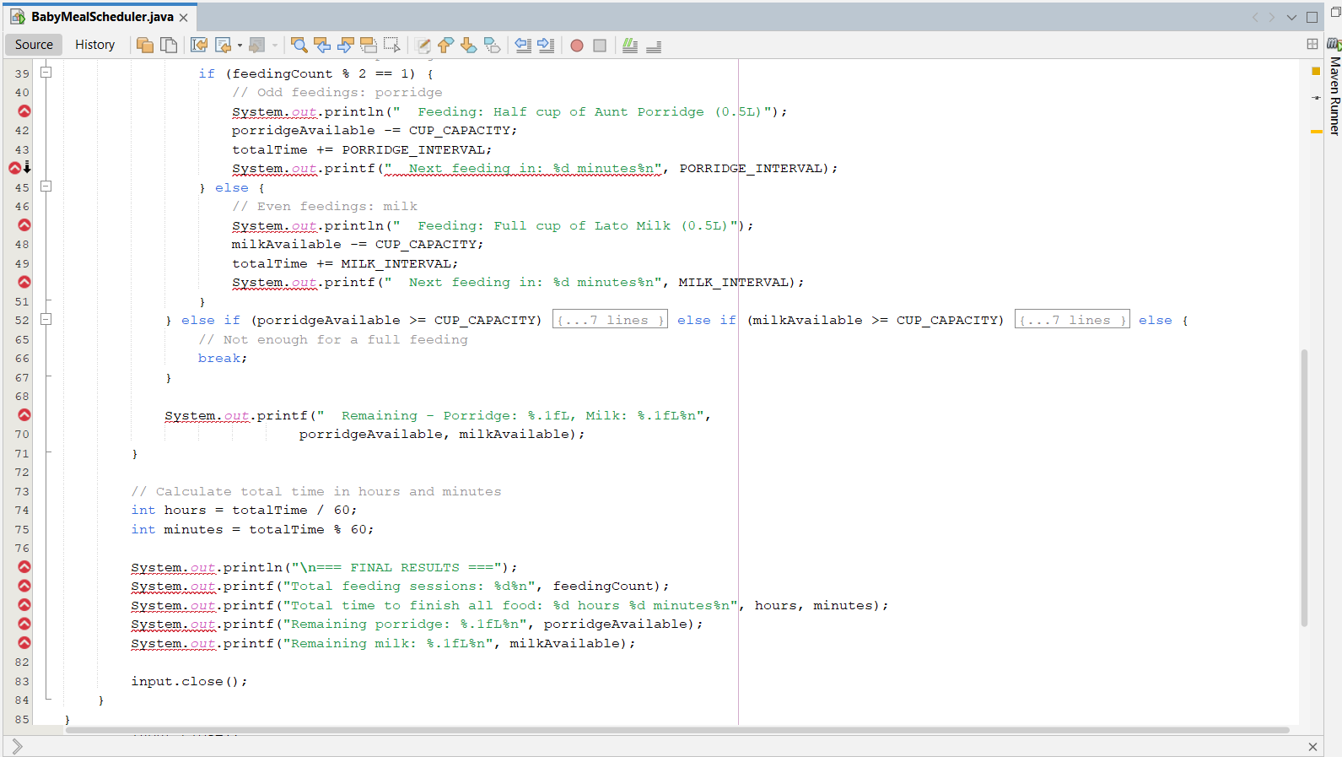
Output:
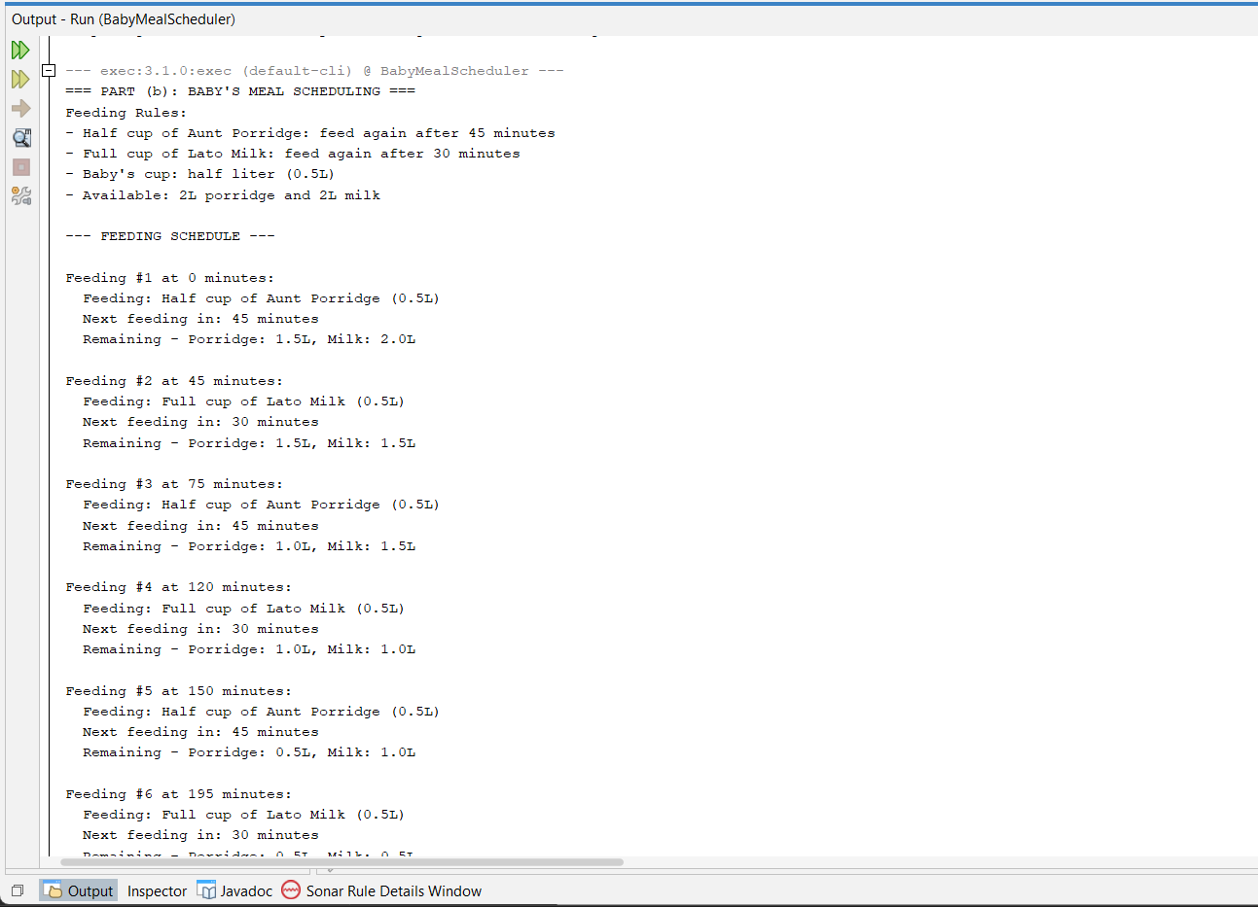
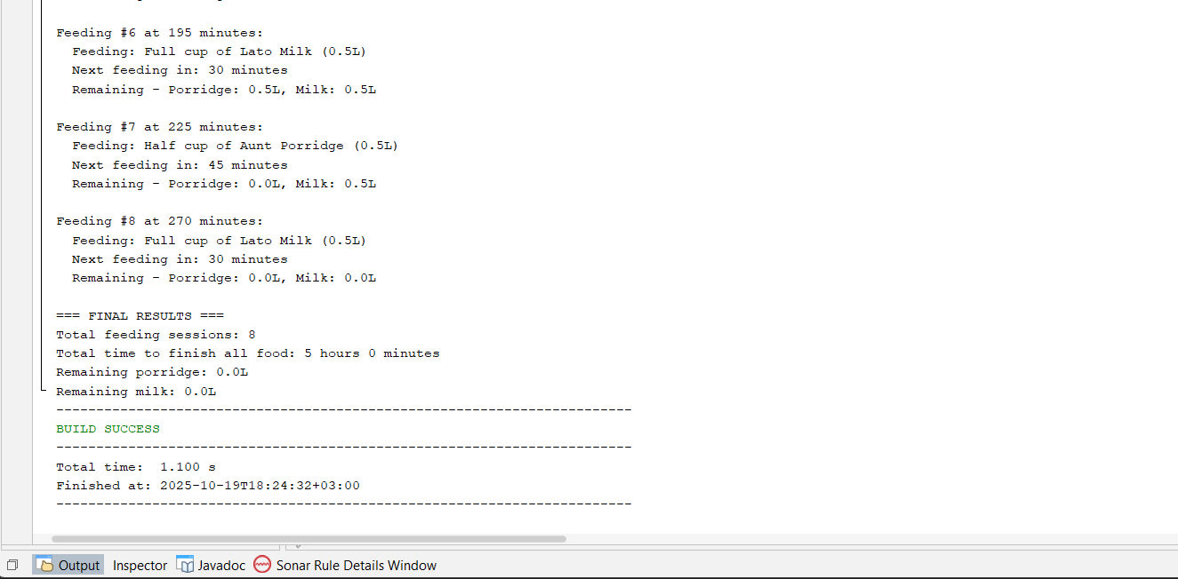
GitHub Link:
https://github.com/joepro29/BabyMealScheduler.git

(c) Telecom Billing System.

